**Experiment 5**

# Student Name: Jasneek Singh UID-22BET10123

**Branch:** IT **Section/Group-703/B**

**Semester:** 6th **Date of Performance18/2/2025 Subject Name:** Advanced Programming Lab-2 **Subject Code:** 22ITP-351

**Problem -1**

1. **Aim:** Merge Sorted Array

# Objective:

* + **Understand Merging of Sorted Arrays**: - The goal is to combine two sorted arrays into one sorted array. This helps in learning how to correctly place elements while maintaining order.
  + **Efficient In-Place Merging**:-The merging should be done within nums1 without using extra space. This improves efficiency and helps in solving problems that require modifying arrays directly.
  + **Using Two-Pointer Technique**: - The two-pointer approach helps merge arrays efficiently by placing larger elements first. This reduces unnecessary shifts and improves the merging process.
  + **Handling Edge Cases**: - It is important to consider cases like an empty nums2 or extra zeros in nums1. This ensures that the algorithm works for all possible inputs.
  + **Improving Problem-Solving Skills**:- Solving this problem enhances logical thinking and coding skills. It also prepares you for technical interviews that require optimizing solutions.

# Implementation/Code:

class Solution { public:

void merge(vector<int>& nums1, int m, vector<int>& nums2, int n) { int i = m - 1, j = n - 1, k = m + n - 1;

while (i >= 0 && j >= 0) { if (nums1[i] > nums2[j]) {

nums1[k] = nums1[i];

i--;

} else {

nums1[k] = nums2[j]; j--

; }

k--;

}

while (j >= 0) { nums1[k] = nums2[j];

j--;

k--;

}

} };

# Output:

**Figure 1**

# Learning Outcome:

* + **Ability to Merge Sorted Arrays**: - You will learn to merge two sorted arrays efficiently while maintaining their order in a single array. This helps in understanding how to correctly insert elements in the given space without using extra memory.
  + **Understanding of Two-Pointer Approach**: - The two-pointer method allows efficient merging without extra space. This improves problem-solving skills and helps in solving other array-related problems.
  + **Handling Edge Cases Confidently**: - You will understand how to manage cases like an empty nums2 or trailing zeros in nums1. This ensures that your solution is reliable and works in all scenarios.
  + **Writing Optimized Code**: - Learning this method helps in writing optimized code with minimal time complexity. This makes your solutions more efficient and improves performance.
  + **Problem-Solving for Interviews**: - This problem is commonly asked in coding interviews. Practicing it will improve your logical thinking and help you solve similar array-based problems quickly.

**Problem-2**

1. **Aim:** Sort Colors

# Objectives:

* + **Sorting Colors Without Sorting Function**: - The goal is to sort an array containing 0s, 1s, and 2s without using built-in sorting. This helps in learning efficient ways to organize data manually.
  + **Using the Dutch National Flag Algorithm**: - The algorithm helps in sorting the array in a single pass. This improves understanding of how to arrange elements using multiple pointers.
  + **Efficient In-Place Sorting**: - The sorting is done without extra space, modifying the array directly. This teaches how to optimize memory usage in coding problems.
  + **Handling Different Cases Easily**: - The method ensures that all numbers are placed in the correct order. It helps in dealing with cases where numbers are shuffled randomly.
  + **Improving Logical Thinking and Speed**: - Understanding this approach improves coding skills and speed. It is useful for solving interview questions and competitive programming problems.

# Implementation/Code:

class Solution { public: void sortColors(vector<int>& nums) { int low = 0, mid = 0, high = nums.size() - 1;

while (mid <= high) { if (nums[mid] == 0) { swap(nums[low], nums[mid]); low++; mid++;

} else if (nums[mid] == 1) { mid++;

} else {

swap(nums[mid], nums[high]);

high--;

}

}

}

};

# Output:

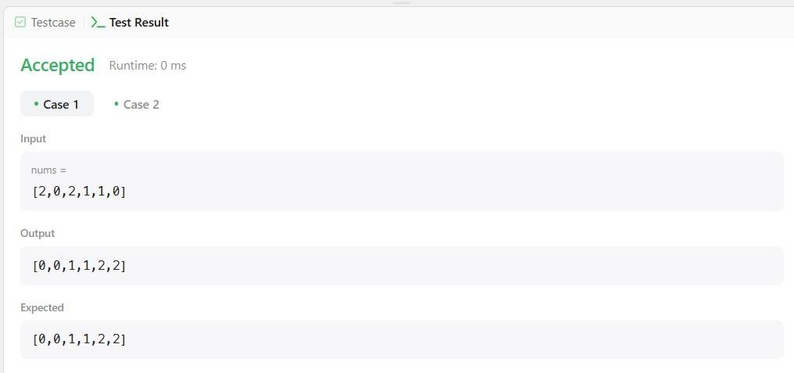

**Figure 2**

# Learning Outcomes:

* + **Sorting Arrays Without Extra Space**:-You will learn how to sort an array without using extra memory. This helps in understanding space-efficient solutions.
  + **Mastering the Two-Pointer Approach**: - The two-pointer method helps in arranging elements quickly. It makes solving similar sorting problems easier.
  + **Handling Complex Sorting Problems**: - You will gain confidence in solving sorting problems efficiently. This improves your problem-solving ability in technical interviews.
  + **Writing Optimized Code**: - The approach ensures sorting is done in one pass. This makes the code faster and reduces unnecessary computations.
  + **Better Preparation for Interviews**: - This problem is commonly asked in coding interviews. Practicing it will strengthen your ability to solve sorting-based challenges.

**Problem – 3**

1. **Aim:** Find Peak Element

# Objectives:

* + **Understanding Peak Elements**: - The objective is to identify a peak element in an array where each element is compared with its neighbors. This helps in recognizing patterns within arrays and solving related problems.
  + **Implementing Binary Search**: - The goal is to apply the binary search approach to find a peak element efficiently. This ensures that the solution runs in O(log n) time instead of a linear scan.
  + **Optimizing Problem-Solving Skills**: - This problem helps in improving logical reasoning by teaching how to make decisions based on comparisons. Understanding how to narrow down the search space efficiently is a key takeaway.
  + **Handling Special Cases**: - The objective is to handle various scenarios, such as peaks appearing at the start, middle, or end of the array. This ensures a complete and robust solution.
  + **Enhancing Algorithmic Thinking**: - By working on this problem, you will strengthen your ability to design and implement optimized algorithms. This contributes to developing better coding and debugging skills.

# Implementation/Code:

class Solution { public:

int findPeakElement(vector<int>& nums) { int left = 0, right = nums.size() - 1; while (left < right) { int mid = left + (right - left) / 2; if (nums[mid] > nums[mid + 1]) {

} else {

}

}

right = mid; left = mid + 1;

return left;

}

};

# Output:

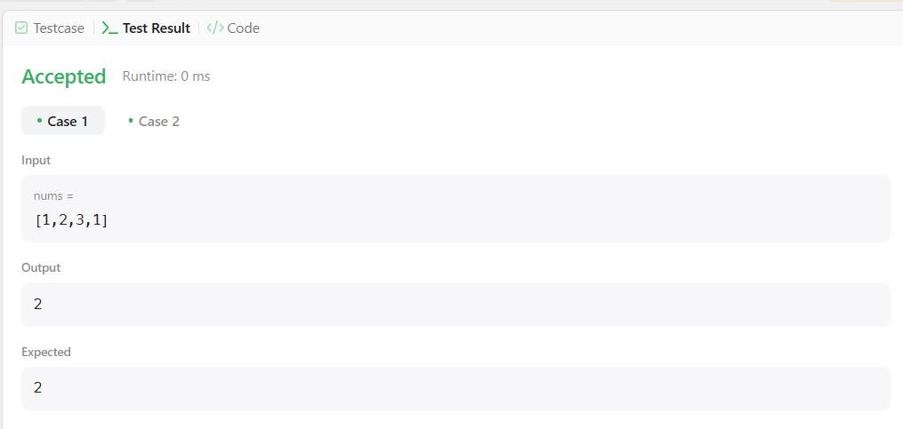

**Figure 3**

# Learning Outcomes

* + **Efficient Peak Finding**: - You will learn how to locate a peak element without scanning the entire array, using a smarter approach with binary search.
  + **Mastering Binary Search Variations**: - You will understand how binary search can be adapted for different problems beyond simple number searching.
  + **Developing a Logical Approach**: - You will improve your ability to break down problems logically, making it easier to apply efficient solutions in coding interviews and real-world tasks.
  + **Understanding Search Space Reduction**: - You will gain insights into how reducing the search space step by step can lead to significant performance improvements.
  + **Building Optimized and Scalable Solutions**:- You will develop the skills to write code that is both time-efficient and scalable, a crucial requirement for competitive programming and software development.